User Guide 45 Street Addressing
Purpose of this User Guide
The purpose of this User Guide is to assist Responsible Authorities on how to prepare and submit street address allocations for certification applications in SPEAR.

Who should read this?
Primary audience: Responsible Authorities
For information: Applicant Contacts
Introduction
Responsible Authorities can enter new street addresses directly into SPEAR or import addresses from an M1 spreadsheet file. This addressing information is stored and submitted weekly to Information Services Division (ISD)'s Notification for Editing Service (NES) directly on behalf of the Responsible Authority to support map base updates in a timely and consistent manner.
Once the new street addressing is processed by NES, the NES reference number will be displayed in SPEAR.
New Street Address Allocations must be provided by the Responsible Authority, prior to certifying the plan.
  - Adding New Street Address Allocations directly in SPEAR.
Responsible Authorities can choose ‘Add New Street Address Allocations’ from the ‘Other Actions’ list on the Details screen at any time prior to issuing certification.
Select between the following options:
- ‘Street Addressing for this plan to be entered into SPEAR’ or
- ‘Street Addressing cannot be entered for this application’.
- If addressing cannot be completed, select the relevant reason and click ‘save’.
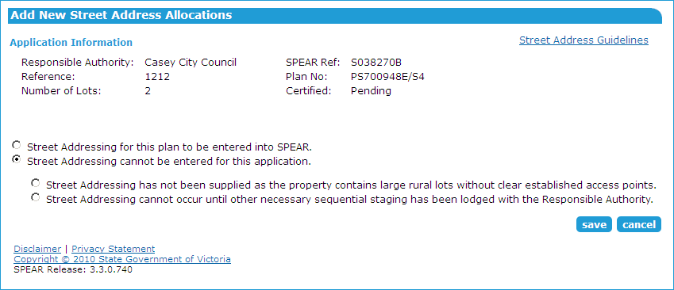
If addressing is to be entered, select either:
- ‘Enter’ or
- ‘Import’
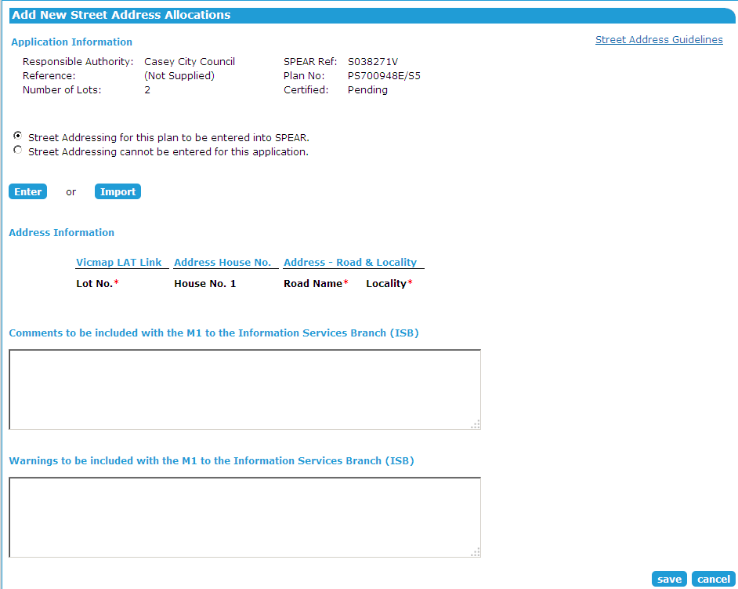

Click ‘Enter’ to display the address fields. These sections can be expanded or collapsed as required. Enter the address information for the first lot and click ‘add now’.
For subsequent addresses, click the ‘Duplicate Address' icon to add additional rows, or use the 'Enter new address' button to add additional columns.
Alternatively, select the ‘Import’ option for the address data to be imported from an M1 v12 spreadsheet. Select ‘Browse’ to locate and attach the M1 file (.xls or .csv file format required). If multiple subdivisions are included within the one M1, SPEAR will extract only the relevant addresses for that subdivision. The template is available from the Import screen.
An option to send comments or warnings to the Information Services Division (ISD) is available via the text boxes. Once completed click ‘save' to return to the Details screen.
From the Details screen, the New Street Address Allocations document must be authenticated to complete the process.
  - Recheck Street Addressing
After street addressing has been supplied, but prior to certification, the Applicant Contact may choose to modify the plan. If changes to the plan effect previously supplied addressing (i.e. the new plan version modifies the parcel structure of the plan), then the Responsible Authority will have the opportunity to recheck addressing.
When the plan is modified, SPEAR asks the surveyor if the parcellation is being modified at all, and if so, the Responsible Authority will have a mandatory action to ‘Recheck New Street Address Allocations’.
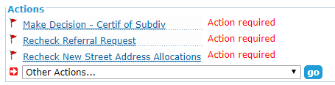
Clicking on the action will prompt the user to consider the addressing requirement:
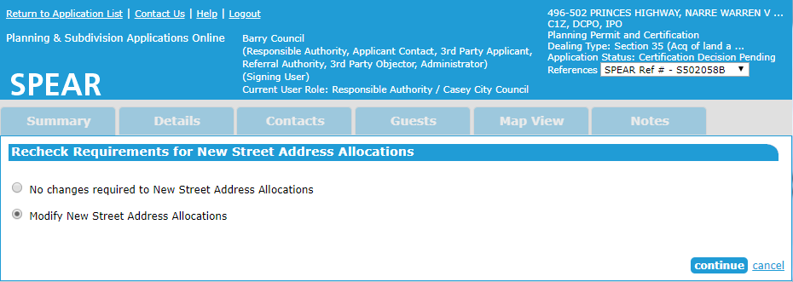
Selecting the ‘No changes required to New Street Address Allocations’ option will close the action and leave the existing addressing as is.
Selecting the ‘Modify New Street Address Allocations’ will take the user to the ‘Confirm / Modify New Street Address Allocations’ screen where addressing can be modified.

Need more information?
Further information on this topic can be found by:
- Visiting the SPEAR website www.spear.land.vic.gov.au/SPEAR
- Contacting the SPEAR Service Desk on 9194 0612 or email spear.info@delwp.vic.gov.au
- Selecting the Help link in the relevant area of the system.

